Module-II
(DBMS)

The terms Serializability in DBMS
A schedule is serialized if it is equivalent to a serial schedule. A concurrent schedule must ensure it is the same as if executed serially means one after another. It refers to the sequence of actions such as read, write, abort, commit is performed in a serial manner.

Example
Let’s take two transactions T1 and T2,
If both transactions are performed without interfering each other then it is called as serial schedule, it can be represented as follows –
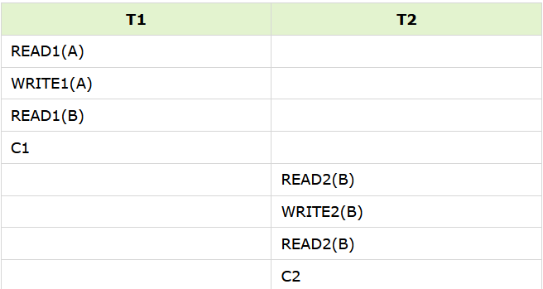

Non serial schedule − When a transaction is overlapped between the transaction T1 and T2.

Example
Consider the following example −

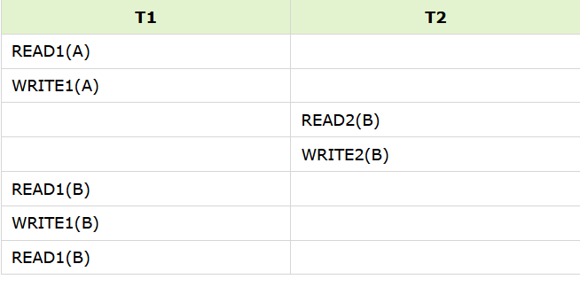

3. Serializable schedule
- The Serializability of schedules is used to find non-serial schedules that allow the transaction to execute concurrently without interfering with one another.
- It identifies which schedules are correct when executions of the transaction have interleaving of their operations.
- A non-serial schedule will be serializable if its result is equal to the result of its transactions executed serially.
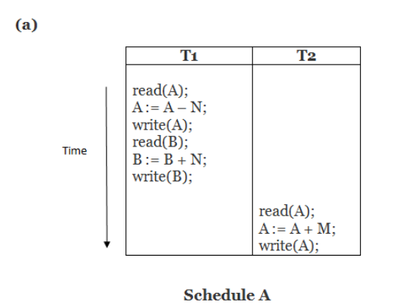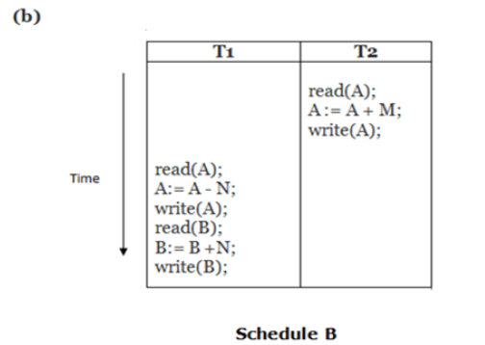
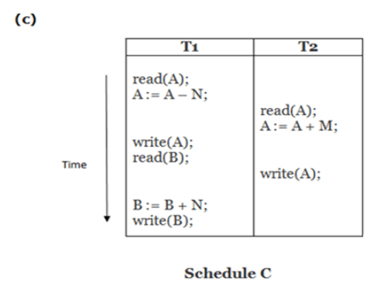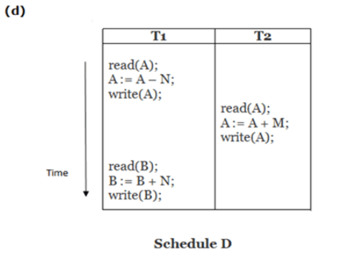
Schedule A and Schedule B are serial schedule.
Schedule C and Schedule D Are Non-serial schedule.

Testing of Serializability
Serialization Graph is used to test the Serializability of a schedule.
Assume a schedule S. For S, we construct a graph known as precedence graph. This graph has a pair G = (V, E), where V consists a set of vertices, and E consists a set of edges. The set of vertices is used to contain all the transactions participating in the schedule. The set of edges is used to contain all edges Ti ->Tj for which one of the three conditions holds:
- Create a node Ti → Tj if Ti executes write (Q) before Tj executes read (Q).
- Create a node Ti → Tj if Ti executes read (Q) before Tj executes write (Q).
- Create a node Ti → Tj if Ti executes write (Q) before Tj executes write (Q).
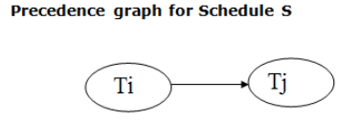
- If a precedence graph contains a single edge Ti → Tj, then all the instructions of Ti are executed before the first instruction of Tj is executed.
- If a precedence graph for schedule S contains a cycle, then S is non-serializable. If the precedence graph has no cycle, then S is known as serializable.

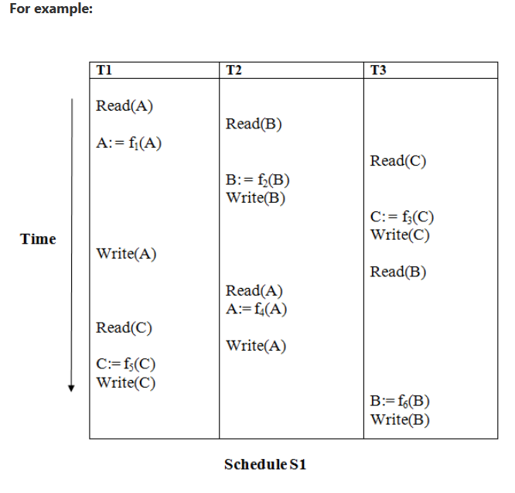
Explanation:
Read(A): In T1, no subsequent writes to A, so no new edges
Read(B): In T2, no subsequent writes to B, so no new edges
Read(C): In T3, no subsequent writes to C, so no new edges
Write(B): B is subsequently read by T3, so add edge T2 → T3
Write(C): C is subsequently read by T1, so add edge T3 → T1
Write(A): A is subsequently read by T2, so add edge T1 → T2
Write(A): In T2, no subsequent reads to A, so no new edges
Write(C): In T1, no subsequent reads to C, so no new edges
Write(B): In T3, no subsequent reads to B, so no new edges
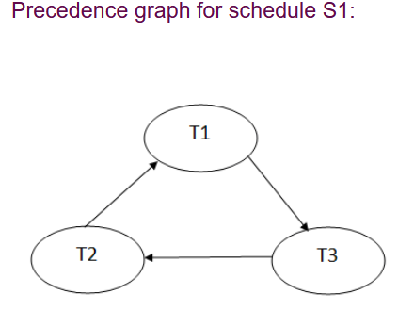

Conflict Serializable Schedule
- A schedule is called conflict Serializability if after swapping of non-conflicting operations, it can transform into a serial schedule.
- The schedule will be a conflict serializable if it is conflict equivalent to a serial schedule.

Conflicting Operations
The two operations become conflicting if all conditions satisfy:
- Both belong to separate transactions.
- They have the same data item.
- They contain at least one write operation.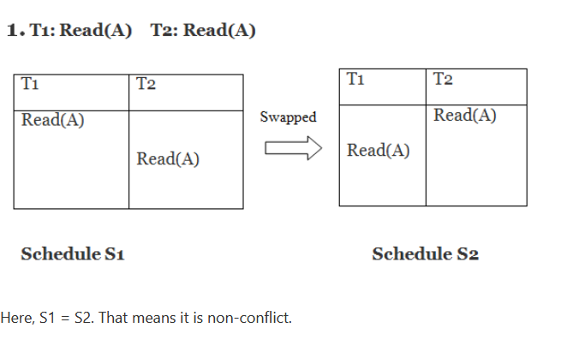
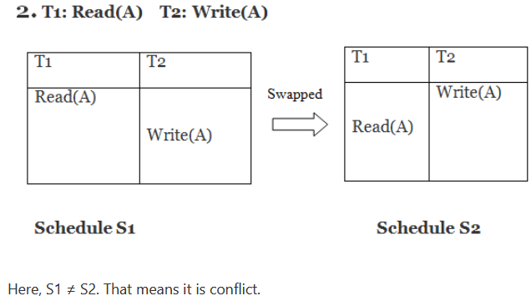

Conflict Equivalent
In the conflict equivalent, one can be transformed to another by swapping non-conflicting operations. In the given example, S2 is conflict equivalent to S1 (S1 can be converted to S2 by swapping non-conflicting operations).
Two schedules are said to be conflict equivalent if and only if:
- They contain the same set of the transaction.
- If each pair of conflict operations are ordered in the same way.

Example:
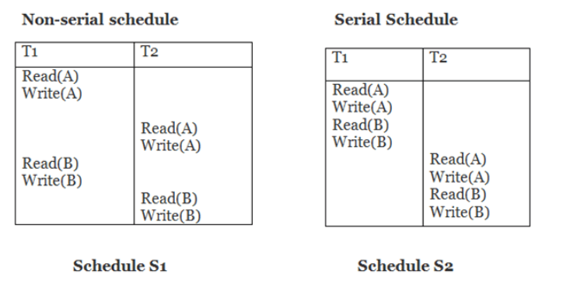
Schedule S2 is a serial schedule because, in this, all operations of T1 are performed before starting any operation of T2. Schedule S1 can be transformed into a serial schedule by swapping non-conflicting operations of S1.

After swapping of non-conflict operations, the schedule S1 becomes:
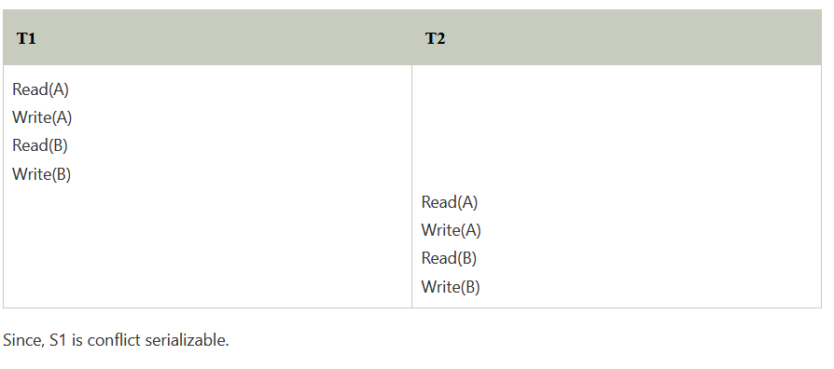

View Serializability
A schedule is view-Serializability if it is viewed equivalent to a serial schedule.
The rules it follows are as follows −
- T1 is reading the initial value of A, then T2 also reads the initial value of A.
- T1 is the reading value written by T2, then T2 also reads the value written by T1.
- T1 is writing the final value, and then T2 also has the write operation as the final value.

View Equivalent
Two schedules S1 and S2 are said to be view equivalent if they satisfy the following conditions:

1. Initial Read
An initial read of both schedules must be the same. Suppose two schedule S1 and S2. In schedule S1, if a transaction T1 is reading the data item A, then in S2, transaction T1 should also read A.
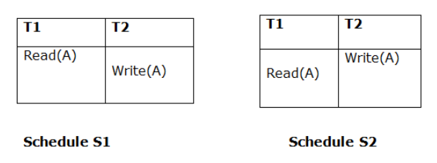
Above two schedules are view equivalent because Initial read operation in S1 is done by T1 and in S2 it is also done by T1.

2. Updated Read
In schedule S1, if Ti is reading A which is updated by Tj then in S2 also, Ti should read A which is updated by Tj.
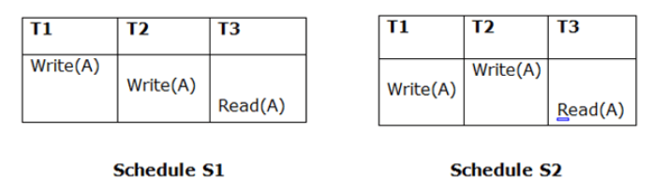
Above two schedules are not view equal because, in S1, T3 is reading A updated by T2 and in S2, T3 is reading A updated by T1.

3. Final Write
A final write must be the same between both the schedules. In schedule S1, if a transaction T1 updates A at last then in S2, final writes operations should also be done by T1.
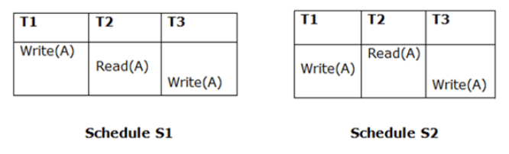
Above two schedules is view equal because Final write operation in S1 is done by T3 and in S2, the final write operation is also done by T3.
Example:
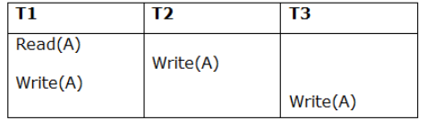
Schedule S
With 3 transactions, the total number of possible schedule
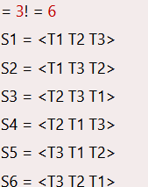
Taking first schedule S1:
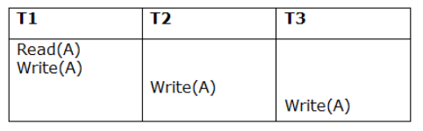
Schedule S1
Step 1: final updating on data items
In both schedules S and S1, there is no read except the initial read that's why we don't need to check that condition.
Step 2: Initial Read
The initial read operation in S is done by T1 and in S1, it is also done by T1.
Step 3: Final Write
The final write operation in S is done by T3 and in S1, it is also done by T3. So, S and S1 are view Equivalent.
The first schedule S1 satisfies all three conditions, so we don't need to check another schedule.
Hence, view equivalent serial schedule is:
T1 → T2 → T3

Recoverability of Schedule
Sometimes a transaction may not execute completely due to a software issue, system crash or hardware failure. In that case, the failed transaction has to be rollback. But some other transaction may also have used value produced by the failed transaction. So we also have to rollback those transactions.
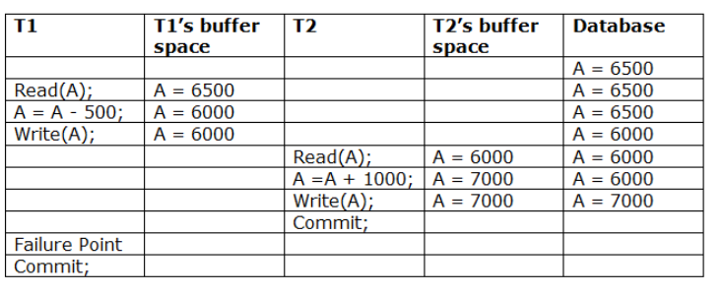
The above table 1 shows a schedule which has two transactions. T1 reads and writes the value of A and that value is read and written by T2. T2 commits but later on, T1 fails. Due to the failure, we have to rollback T1. T2 should also be rollback because it reads the value written by T1, but T2 can't be rollback because it already committed. So this type of schedule is known as irrecoverable schedule.
Irrecoverable schedule: The schedule will be irrecoverable if Tj reads the updated value of Ti and Tj committed before Ti commit.
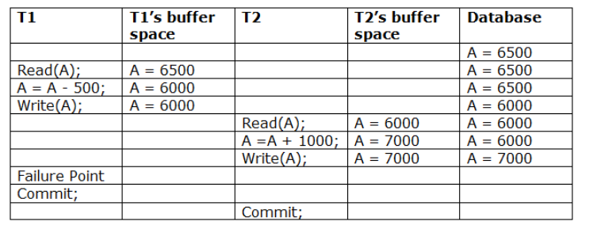
The above table 2 shows a schedule with two transactions. Transaction T1 reads and writes A, and that value is read and written by transaction T2. But later on, T1 fails. Due to this, we have to rollback T1. T2 should be rollback because T2 has read the value written by T1. As it has not committed before T1 commits so we can rollback transaction T2 as well. So it is recoverable with cascade rollback.
Recoverable with cascading rollback: The schedule will be recoverable with cascading rollback if Tj reads the updated value of Ti. Commit of Tj is delayed till commit of Ti.
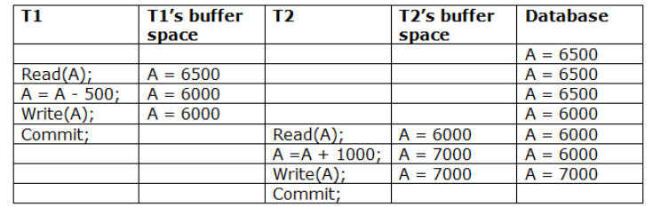
The above Table 3 shows a schedule with two transactions. Transaction T1 reads and write A and commits, and that value is read and written by T2. So this is a cascade less recoverable schedule.

Failure Classification
To find that where the problem has occurred, we generalize a failure into the following categories:
- Transaction failure
- System crash
- Disk failure

1. Transaction failure
The transaction failure occurs when it fails to execute or when it reaches a point from where it can't go any further. If a few transaction or process is hurt, then this is called as transaction failure.
Reasons for a transaction failure could be -
  - Logical errors: If a transaction cannot complete due to some code error or an internal error condition, then the logical error occurs.
  - Syntax error: It occurs where the DBMS itself terminates an active transaction because the database system is not able to execute it.
For example, the system aborts an active transaction, in case of deadlock or resource unavailability.

2. System Crash
  - System failure can occur due to power failure or other hardware or software failure. Example: Operating system error.

3. Disk Failure
  - It occurs where hard-disk drives or storage drives used to fail frequently. It was a common problem in the early days of technology evolution.
  - Disk failure occurs due to the formation of bad sectors, disk head crash, and unreachability to the disk or any other failure, which destroy all or part of disk storage.

Query Processing in DBMS
Query Processing is the activity performed in extracting data from the database. In query processing, it takes various steps for fetching the data from the database. The steps involved are:
- Parsing and translation
- Optimization
- Evaluation
The query processing works in the following way:

Parsing and Translation
As query processing includes certain activities for data retrieval. Initially, the given user queries get translated in high-level database languages such as SQL. When a user executes any query, for generating the internal form of the query, the parser in the system checks the syntax of the query, verifies the name of the relation in the database, the tuple, and finally the required attribute value.
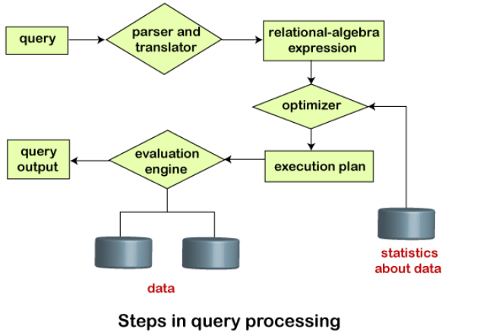
In SQL, a user wants to fetch the records of the employees whose salary is greater than or equal to 10000. For doing this, the following query is undertaken:
select emp_name from Employee where salary>10000;
Thus, to make the system understand the user query, it needs to be translated in the form of relational algebra. We can bring this query in the relational algebra form as:
- σ_{salary>10000} (π_{salary} (Employee))
- π_{salary} (σ_{salary>10000} (Employee))
After translating the given query, we can execute each relational algebra operation by using different algorithms. So, in this way, a query processing begins its working.

Optimization
- The cost of the query evaluation can vary for different types of queries. Although the system is responsible for constructing the evaluation plan, the user does need not to write their query efficiently.
- Usually, a database system generates an efficient query evaluation plan, which minimizes its cost. This type of task performed by the database system and is known as Query Optimization.
- For optimizing a query, the query optimizer should have an estimated cost analysis of each operation. It is because the overall operation cost depends on the memory allocations to several operations, execution costs, and so on.

Evaluation
For this, with addition to the relational algebra translation, it is required to annotate the translated relational algebra expression with the instructions used for specifying and evaluating each operation. Thus, after translating the user query, the system executes a query evaluation plan.

Query Evaluation Plan
- In order to fully evaluate a query, the system needs to construct a query evaluation plan.
- The annotations in the evaluation plan may refer to the algorithms to be used for the particular index or the specific operations.
- Such relational algebra with annotations is referred to as Evaluation Primitives. The evaluation primitives carry the instructions needed for the evaluation of the operation.
- Thus, a query evaluation plan defines a sequence of primitive operations used for evaluating a query. The query evaluation plan is also referred to as the query execution plan.
Query Execution Engine:
Query Execution Engine is responsible for generating the output of the given query. It takes the query execution plan, executes it, and finally makes the output for the user query.
Cost-based Query Optimization
The DBMS’s optimizer will use an internal cost model to estimate the execution cost for a particular query plan. This provides an estimate to determine whether one plan is better than another without having to actually run the query.
from estimating the usage of different resources:
• CPU: Small cost; tough to estimate.
• Disk: Number of block transferred.
• Memory: Amount of DRAM used.
• Network: Number of messages transfer ed
To accomplish this, the DBMS stores internal statistics about tables, attributes, and indexes in its internal catalog. Different systems update the statistics at different times. Commercial DBMS have way more robust and accurate statistics compared to the open source systems. These are estimates and thus the cost estimates will often be inaccurate.
Total Cost:
Summation of all cost factors
Total cost = CPU cost + I/O cost + communication cost
CPU cost = unit instruction cost * no. of instructions
I/O cost = unit disk I/O cost * no. of disk I/Os
communication cost = message initiation + transmission

Response Time:
Elapsed time between the initiation and the completion of a query
Response time = CPU time + I/O time + communication time
CPU time = unit instruction time * no. of sequential instructions
I/O time = unit I/O time * no. of sequential I/Os
communication time = unit msg initiation time * no. of sequential msg+ unit transmission time * no. of sequential bytes
Example
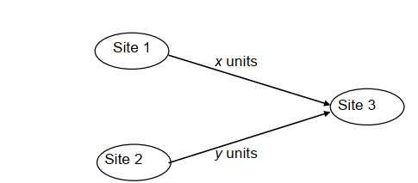
Assume that only the communication cost is considered
Total time = 2 message initialization time + unit transmission time * (x+y)
Response time = max {time to send x from 1 to 3, time to send y from 2 to 3}
Time to send x from 1 to 3 = message initialization time + unit transmission time * x
Time to send y from 2 to 3 = message initialization time + unit transmission time * y

Measures of Query Cost in DBMS
Query Cost is a cost in which the enhancer considers what amount of time your query will require (comparative with absolute clump time). Then the analyser attempts to pick the most ideal query plan by taking a glance at your inquiry and insights of your information, attempting a few execution designs, and choosing the most inexpensive of them.
The measures of query cost in DBMS can be done by creating a framework that can make numerous designs for an inquiry. It tends to be finished by the means of contrasting every conceivable arrangement as far as their assessed cost. For working out the net assessed cost of any arrangement, the expense of every activity inside an arrangement ought to be set in a deterministic and consolidated cost to get the net assessed cost of the query assessment plan.
Example: We utilize the number of square exchanges that is basically the block from the disk and the quantity of the disk seeks to appraise the expense of a query assessment plan. Assuming that the disk subsystem takes a normal of tT seconds to move a square of information and has a normal block access time (disk lookup time in addition to rotational idleness) of tS seconds, then, at that point, an activity that moves b obstructs and performs S looks for would take b ∗ tT + S ∗ tS seconds. The upsides of tT and tS should be aligned for the disk framework utilization, however, normal qualities for top-end disk today would be tS = 4 milliseconds and tT = 0.1 milliseconds, expecting a 4-kilobyte block size and an exchange pace of 40 megabytes each second.
tT – time to transfer one block
tS – time for one to seek
Cost for b block transfers plus S seeks
b * tT + S * tS
The expense assessment of a query assessment plan is determined the different assets that follow as:
- The number of disk accesses.
- Time of Execution taken by the CPU to execute a query.
- The involved Communication costs in either distributed or parallel database systems.

Concurrency Control
Concurrency Control is the working concept that is required for controlling and managing the concurrent execution of database operations and thus avoiding the inconsistencies in the database. Thus, for maintaining the concurrency of the database, we have the concurrency control protocols.

Concurrency Control Protocols
The concurrency control protocols ensure the atomicity, consistency, isolation, durability and Serializability of the concurrent execution of the database transactions. Therefore, these protocols are categorized as:
- Lock Based Concurrency Control Protocol
- Time Stamp Concurrency Control Protocol
- Validation Based Concurrency Control Protocol
We will understand and discuss each protocol one by one in our next sections.

Lock-Based Protocol
In this type of protocol, any transaction cannot read or write data until it acquires an appropriate lock on it. There are two types of lock:
1. Shared lock:
- It is also known as a Read-only lock. In a shared lock, the data item can only read by the transaction.
- It can be shared between the transactions because when the transaction holds a lock, then it can't update the data on the data item.
2. Exclusive lock:
- In the exclusive lock, the data item can be both reads as well as written by the transaction.
- This lock is exclusive, and in this lock, multiple transactions do not modify the same data simultaneously

There are four types of lock protocols available:

1. Simplistic lock protocol
It is the simplest way of locking the data while transaction. Simplistic lock-based protocols allow all the transactions to get the lock on the data before insert or delete or update on it. It will unlock the data item after completing the transaction.

2. Pre-claiming Lock Protocol
- Pre-claiming Lock Protocols evaluate the transaction to list all the data items on which they need locks.
- Before initiating an execution of the transaction, it requests DBMS for all the lock on all those data items.
- If all the locks are granted, then this protocol allows the transaction to begin. When the transaction is completed then it releases all the lock.
- If all the locks are not granted, then this protocol allows the transaction to rolls back and waits until all the locks are granted.
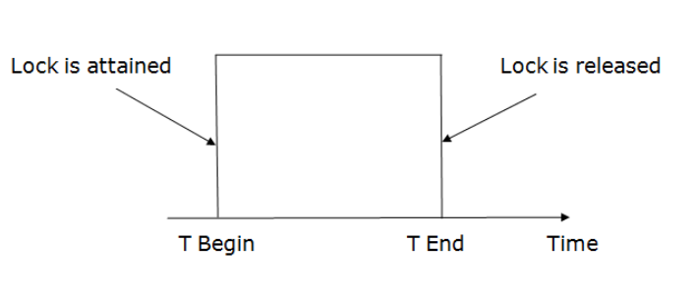

3. Two-phase locking (2PL)
- The two-phase locking protocol divides the execution phase of the transaction into three parts.
- In the first part, when the execution of the transaction starts, it seeks permission for the lock it requires.
- In the second part, the transaction acquires all the locks. The third phase is started as soon as the transaction releases its first lock.
- In the third phase, the transaction cannot demand any new locks. It only releases the acquired locks.
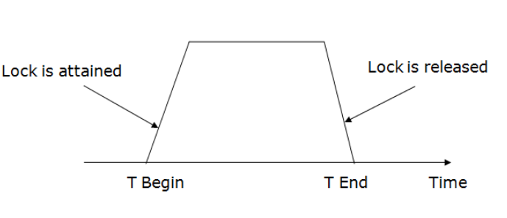
There are two phases of 2PL:
Growing phase: In the growing phase, a new lock on the data item may be acquired by the transaction, but none can be released.
Shrinking phase: In the shrinking phase, existing lock held by the transaction may be released, but no new locks can be acquired.
In the below example, if lock conversion is allowed then the following phase can happen:
- Upgrading of lock (from S(a) to X (a)) is allowed in growing phase.
- Downgrading of lock (from X(a) to S(a)) must be done in shrinking phase.
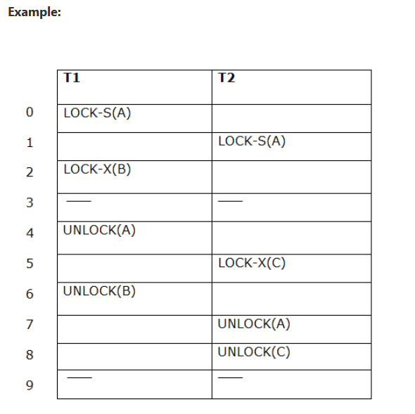
The following way shows how unlocking and locking work with 2-PL.

Transaction T1:
- Growing phase: from step 1-3
- Shrinking phase: from step 5-7
- Lock point: at 3
Transaction T2:
- Growing phase: from step 2-6
- Shrinking phase: from step 8-9
- Lock point: at 6

